`

**Walaa Jamous and Selim Bayrak**

INM704 Agents and Multi-Agents Systems (COURSE 2020-21)



Assignment

Task 3 1-(a)

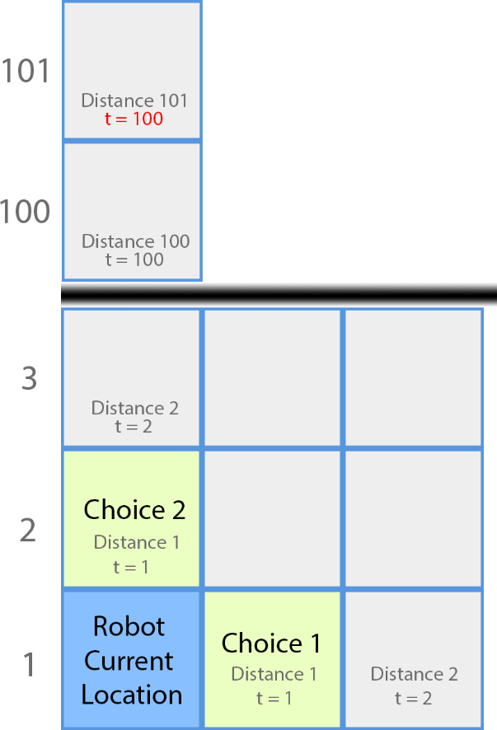The robot will have to calculate the expected utility of each path it can move to, and choose the one with the highest value. Let us first a simple way then take a look at more considerate one. Let us first take a look at the following grid as an example.

Figure 1

$$E=\{ r_{1 \left(i,j\right)}, r_{2 \left(i,j\right)} , r_{3 \left(i,j\right)} \}$$

Let us denote that *t* is an integer that represent the time/distance and

$$0 ≤ t ≤ 100$$

Once it reached 100 it remains 100 as shown in figure 1, cell (101,1). As we define the relation.

$$U= {\left\{\begin{aligned}r_{1 \left(i,j\right)}=20*\left(100-t\right) \\ r_{2 \left(i,j\right)}=30*\left(100-t\right) \\ r_{3 \left(i,j\right)} =50*\left(100-t\right)\end{aligned}\right. }_{Utiliy function}$$

Now, the robot can calculate the expected utility for each choice. Which will be

$${Expected Utility}_{For each choice}= \sum_{k=1}^{3}{{ P}_{k\left(i,j\right)}.U_{k\left(i,j\right)}}$$

Then the robot can choose the highest *EU* for any choice. Denote that at time = 101, t =100 then according to the utility function U = 0.

Figure 2

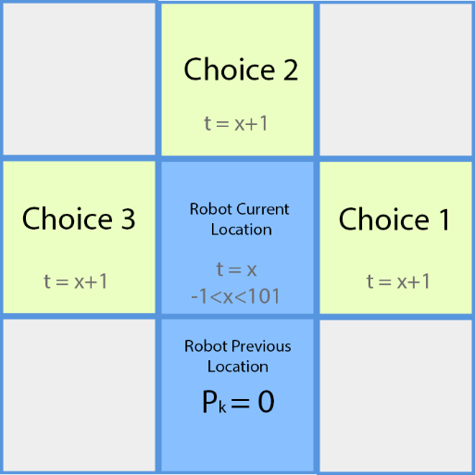Also at all robot path location, the probability of Pk equals zero. Knowing that resources will appear only at time zero, as mention in the question.

**Further Study**

We can further improve the choice of the robot by letting the robot calculate the *Expected Utility*  to the sub-path. In other word, the robot will calculate the for each choice, and for all the sub-choices and so on. Fig 3 illustrate the idea.

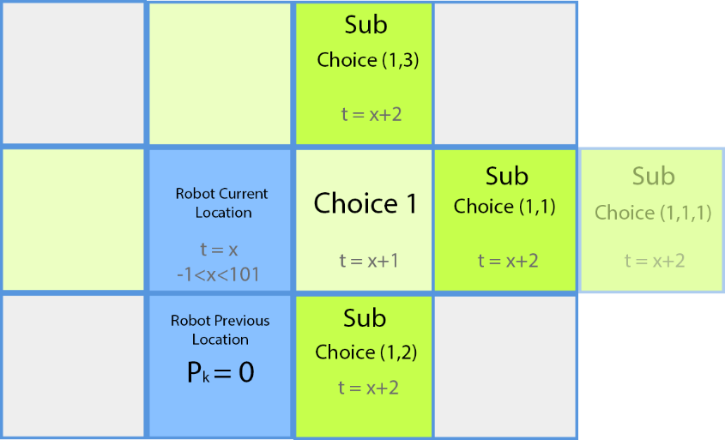

Figure 3

The robot this way has to calculate for < $3^{100}$ different choices, then decide the best path with the most Expected Utility, thus the path might not take the highest choice at every step rather, the robot will consider the sum of all sub choices.

$$Expected Utiliy _{choice\left(i,i_{2}....i_{100}\right)}= \sum_{k=1}^{3}{{ P}_{kchoice\left(i\right)}.U_{kchoice\left(i\right)}} +\sum_{k=1}^{3}{{ P}_{kchoice\left(i,i_{2}\right)}.U_{kchoice\left(i,i_{2}\right)}} + …..$$

Task3 1 B

When Considering cliff the robot must consider a negative Utility at the adjacent cells

$$E=\{ r_{1 \left(i,j\right)}, r_{2 \left(i,j\right)} , r_{3 \left(i,j\right)}, C_{ \left(i,j\right)} \}$$

$$U= {\left\{\begin{aligned}r_{1 \left(i,j\right)}=20*\left(100-t\right) \\ r_{2 \left(i,j\right)}=30*\left(100-t\right) \\ r_{3 \left(i,j\right)}=30*\left(100-t\right) \\ C_{ \left(i,j\right)} =-30,000 \end{aligned}\right. }_{Utiliy function}$$

And the expected utility will be as follow.

$${Expected Utility}_{For each choice}= \sum_{k=1}^{3}{{ (P}_{k\left(i,j\right)}.U_{k\left(i,j\right)})} + { P}_{cliff\left(i,j\right)}.C_{\left(i,j\right)}$$

Where the probability of the cliff, *Pcliff* ,is zero if the robot did not sense a cliff.

